**DEPARTMENT OF INFORMATION TECHNOLOGY**

**Course Name and Code:** Data Structures Lab **(**ITL302)

**Semester:** III (Second Year)

**Academic Year:** 2023-24 (Odd Semester)

**Experiment No. 09**

**Aim:** Implementation of Binary Search Technique considering a real-world application.

**Objectives:**

1. To impart knowledge of sorting and searching algorithms.

**Program:**

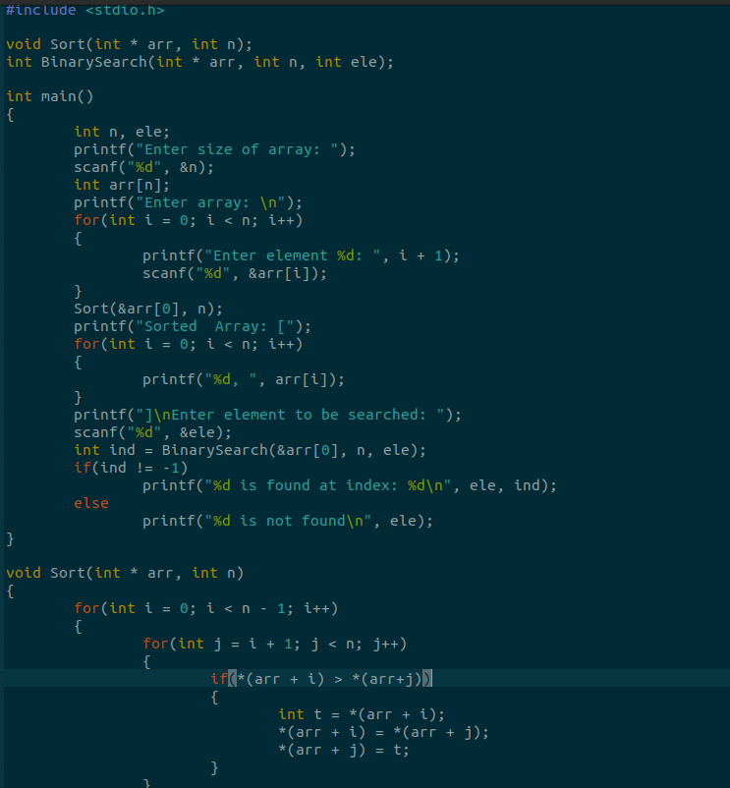

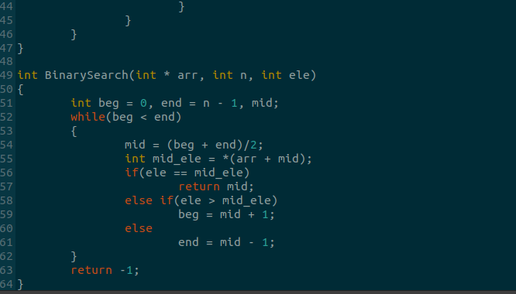

**Output:**

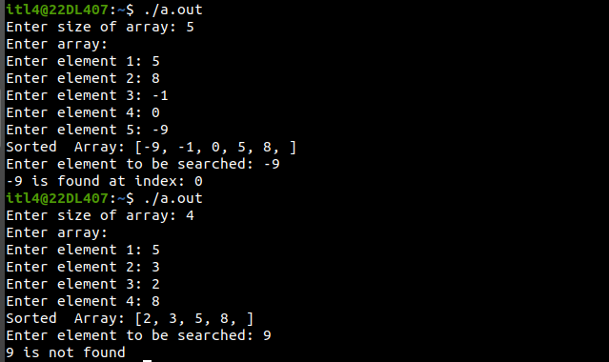

**Conclusion:**

In this experiment we were able to learn different types of searching techniques, their algorithms and time complexities. We also learned how to implement the binary search algorithms in C programming language.

**Outcome:**

Implement sorting and searching techniques for real-world applications.

**Submitted By:**

**Name:** Faizan Dodiya

**Div:** SY/A

**Roll No:** 24